The **Kavli Salon**

**Feb. 19-21, 2017; Havana, Cuba**

The **Kavli Salon** is about to get started from the19th to 21th of Feb. 2017 in Havana, Cuba.

the attendees are as follows:

1. **Richard Axel**, **Premio Nobel 2012.**

[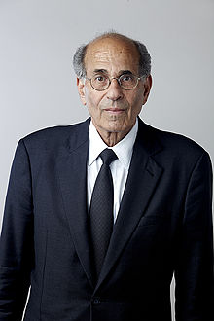](https://en.wikipedia.org/wiki/File:Professor_Richard_Axel_ForMemRS.jpg)

1. **May-Britt Moser Premio Nobel 2014**

[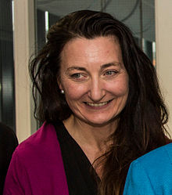](https://en.wikipedia.org/wiki/File:May-Britt_Moser_2014.jpg)

1. **Cori Bargmann**:the coordinator of Obamas’s BRAIN Project

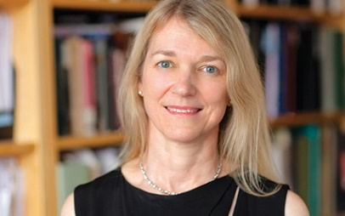

1. Mu-Ming Poo:

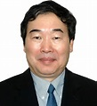

The main organizers of this Salon are Gyuri Buzsaki and May-Britt Moser, and Prof. Pedro is the local organizar in cuba. The salón will last for three days with one day held in CNEURO (see the aganda below) and the other two days in the Nacional Hotel of Cuba.

|  |  |  |
| --- | --- | --- |
| **TIME  TABLE** |  | **CNEURO Thursday Jan 19** |
| 8:00-8:30 |  | **Breakfast National Hotel (*)** |
| 8:30-9:00 |  | **Transfer to Cuban Neuroscience Center (*)** |
| 9:00-9:30 |  | **Quick tour for Cneuro (Coffee and tea at MRI facility)** |
| 9:30-9:45 |  | **Welcome: Pedro Valdes-Sosa and Gyorgy Buzsaki** |
| 9:45-10:00 |  | **Welcome Speech of the Cuban Dignitary: Ismery Talavera Bustamante, Deputy-Minister of Cuban Academy of Science** |
|  |
| 10:00-11:00 |  | **May Britt Moser:´Lost Memory`- art/science. "Musicians/artists: TrondheimSolistene(Norway), Camerata Romeu (Cuba), Bertil Palmar Johansen, composer, Johan Magnus Elvemo, film producer.”** |
| 11:00-11:15 |  | **Coffee break (o)** |
| 11:15-11:45 |  | **David Tank: "Volumetric Two Photon Imaging of Neurons Using Stereoscopy (vTwINS)"** |
| 11:45-12:15 |  | **Mark Churchland : "You should look before you leap, but must you prepare before you move?"** |
| 12:15-12:45 |  | **Mitchel Valdés : "Cuban program for the ageing brain"** |
| 12:45-14:30 |  | **LUNCH "Rancho Palco"** |
| 14:30-15:00 |  | **Luis Velázquez : "The Spino Cerebellar Ataxia in Cuba"** |
| 15:00-15:30 |  | **Jorge Bergado : "Enhancing Neural Plasticity"** |
| 15:30-16:00 |  | **Eddie Chang:" Human Speech Cortex: From Sound to Meaning** |
| 16:00-16:30 |  | **Eve Marder: "Variability Homeostasis and Neuromodulation in a Rhythmic Circuit"** |
| 16:30-16:45 |  | **Coffee break (o)** |
| 16:45-17:15 |  | **Pedro Valdes-Sosa: "The Cuban Human Brain Mapping Projects"** |
| 17:15-17:45 |  | **Karl Friston. " I am therefore I think"** |
| 18:00 |  | **transportation to the Hotel (*)** |
| 20:00 |  | **Dinner at "Fusion Habana"(*)** |
| 22:00 |  | **Free Night** |