The CCC Axis in Translational Brain Mapping
Alan Evans, Pedro Valdes-Sosa, Dezhong Yao

Brain mapping is a field of brain research that emphasizes the use of compute-intensive analysis of multi-domain (neuroimaging, genetics and clinical/behavioural) data to reveal the mechanisms underlying brain disorders and normal brain function. Under the auspices of the Organization for Human Brain Mapping (OHBM), the field has developed a global reach for basic research. However, the translation of this research into the clinic has been limited. Brain mapping leaders from three countries, China, Canada and Cuba, are now joining forces to build a collaborative network that will emphasize the clinical applications of brain mapping research. The CCC Axis takes advantage of complementary strengths and commonalities from the three partners to forge an integrated computational framework for data-sharing and joint analysis of clinical research data, specifically:

All: Scientific and technical expertise in brain mapping ; universal health care
China (lead by Chengdu): Very large patient cohorts
Canada (Montreal): world-leading IT infrastructure (CBRAIN/LORIS)
Cuba (Havana): National screening, networking (LABMAN, Uludag et al., 2009)

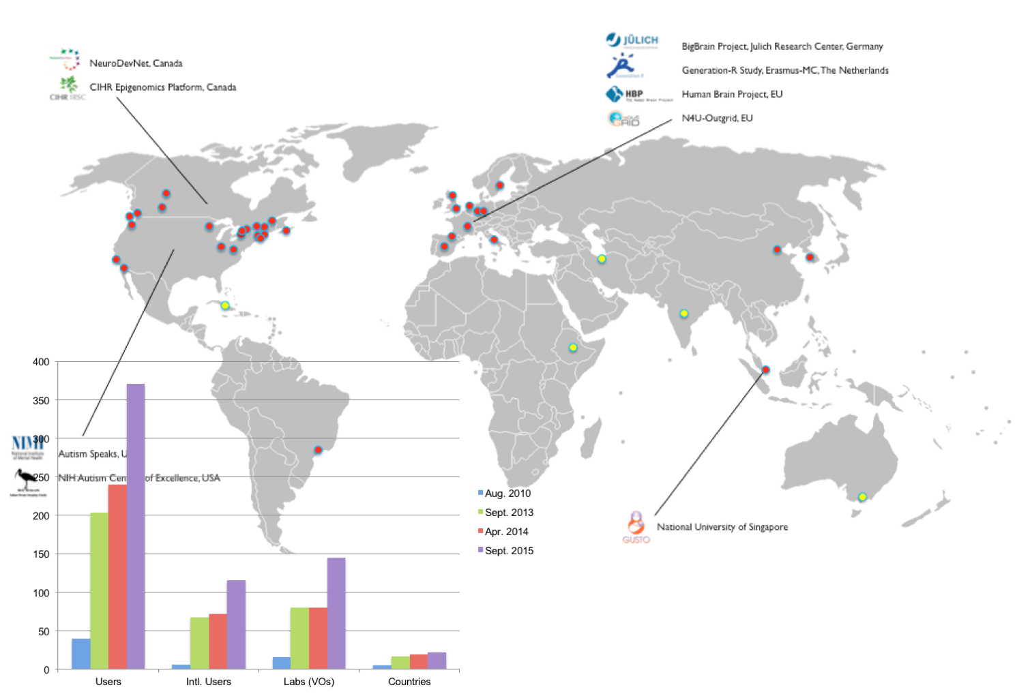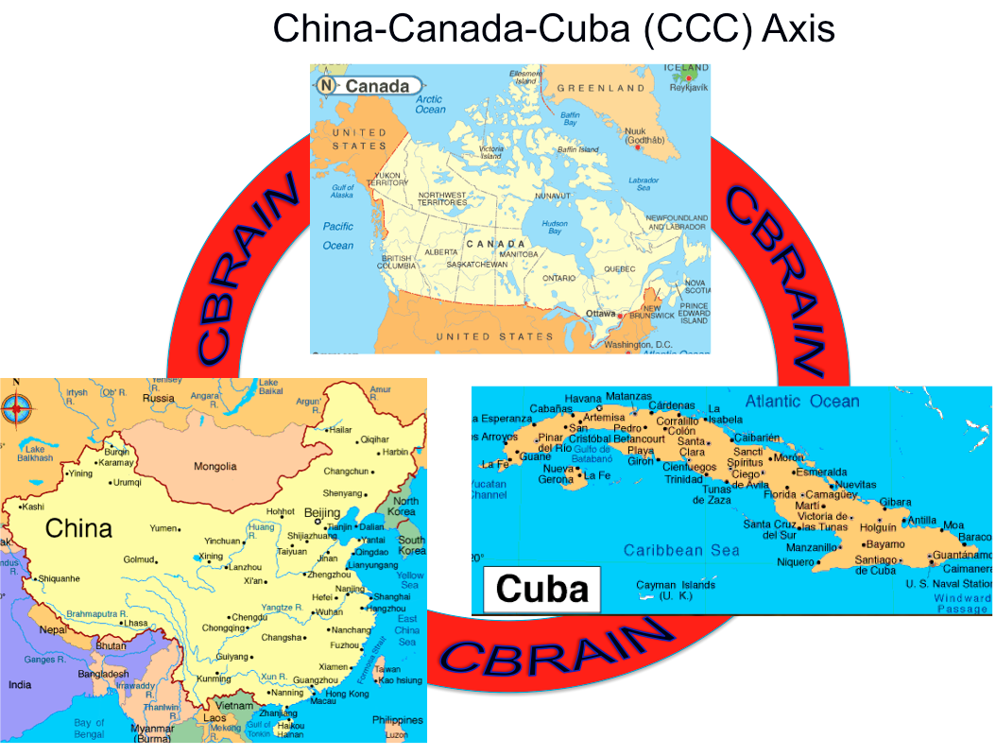
CBRAIN international sites CCC Axis
The CCC Axis will be mediated by the CBRAIN platform, originally developed at McGill University in Canada, that provides compute services to over 400 groups in 22 countries as of June, 2016. CBRAIN allows for data to be shared and processed using high-performance computing resources (Sherif et al., 2014). CBRAIN is associated by a web-based, multi-domain databasing system, LORIS (Das et al., 2012,2015).
In this moment, there are agreements signed between Cuba, Mitchell Valdes (CNEURO, Habana, Cuba), China Dezhong Yao(UESTC, Chengdu, China) and Canada, Alan Evans (McGIll, Montreal, Canada). On the other hand, in September 2016 a agreement between Cuba and Quebec, was signed in front of Premier of Quebec and also a strategic cooperation framework agreement between Chengdu municipal people’s government and BIOCUBAFARMA, for the creation of the China-Canada-Cuba CCC brain mapping project, which was signed on September 2016 with the presence of Chinese Premier Keqiang Le.

References
1. Das S, Zijdenbos AP, Vins D, Harlap J, Evans AC (2012) LORIS: A web-based data management system for multi-center studies Front Neuroinf 5:37
2. Sherif T, Rioux P, Rousseau M-E,..., Das S, Evans AC (2014) CBRAIN: A web-based, distributed computing platform for collaborative neuroimaging research Front Neurosci 8: 54
3. Das S, Glatard T,.., Evans AC (2015) The MNI data-sharing and processing ecosystem Neuroimage (in press, PMID: 26364860)
4. Uludağ K, Evans AC,., Valdés-Sosa P (2009) Latin American Brain Mapping Network (LABMAN) Neuroimage 47(1):312-316

