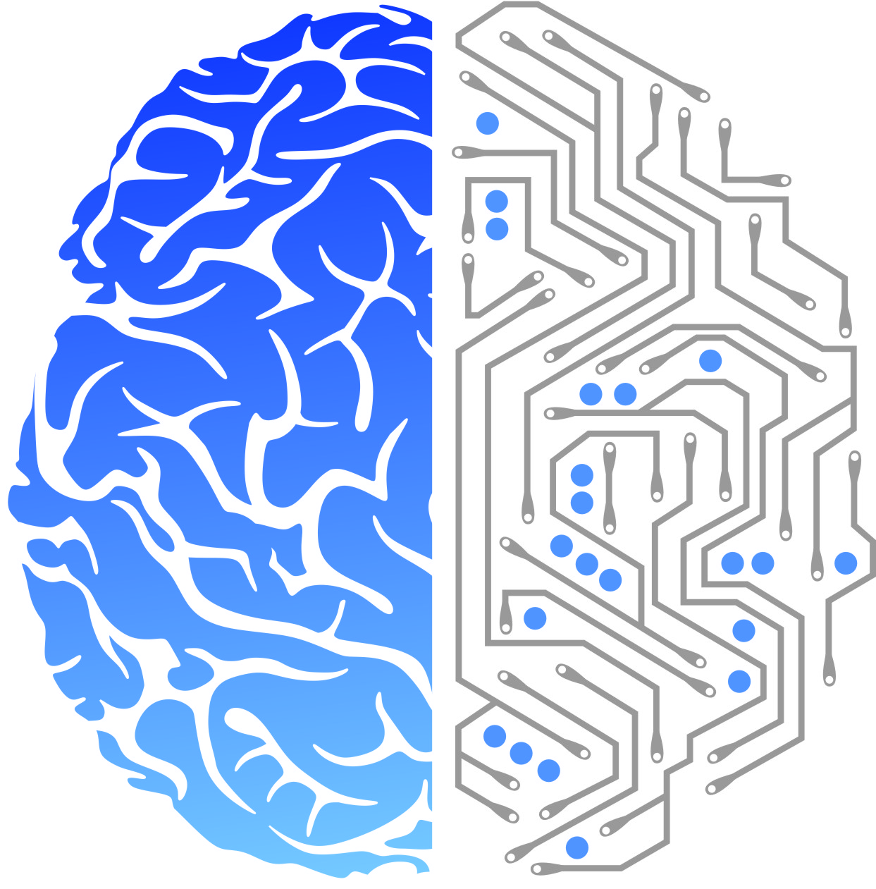
The Center for Information in Medicine and the School of Life Science and Technology are two linked organizations in the University of Electronic Science and Technology of China(UESTC).The School/Center has a doctoral program (PhD issuance authority) and a post-doctoral research station for “Biomedical Engineering” as a primary discipline which ranks No. 10 nationwide. The Center/School also has a master program (Master Degree issuance authority) for “Biology” as a primary discipline. The teaching and research in the school covers multi-disciplines in Biomedical Engineering, Molecular Biology, Neuroscience, and particularly their integration with Information Science. Currently the School/Center has a national research platform “MoST International Joint Research Center for Neuroinformation”, Ministry and Provincial Platforms “MoE Key Laboratory for Neuroinformation”, “Sichuan Province Key Laboratory for High Field MRI Brain Imaging”, as well as “Innovation & Talents Introduction Base for Neuroinformation (111 Project)”.
The School/Center is mainly focusing on research in “Biomedical Engineering”, “Neuroscience and Behavioral Science” and “Biology and Biochemistry”. Due to needs for research development, now the School/Center is welcoming high-end talents from home and abroad, including candidates for “1000 Talents Plan (both long-term and short term, young and senior)”, “Yangtze River Scholars Program (specially appointed, visiting and junior scholars)”and “UESTC 100 Talents Plan”,etc.
- Recruitment Criteria
1、He/she has a doctorate degree issued by a renowned university overseas or from a Chinese “985 Project” university. He/She meets the criteria required in the talents programs mentioned above. For detailed information please contact us.

2、He/She has published high quality academic papers in first-class journals in Neuroscience and Behavioral Science, Biology, Biochemistry and Biomedical Engineering, etc.

3、He/she has already obtained fruitful academic achievements, or has great potential for research capacity so as to contribute to the academic development of the School/Center.

4、The UESTC are willing to deliver lucrative offers. For detailed information please feel free to contact us.
- Contact
Anyone interested in joining us please send your full CV to tangxiaoqiao@uestc.edu.cn, email entitled “UESTC_Life Science School applicant_name”. It is suggested to elaborate your publications and research experience in the CV.
Phone contact: 86-28-83201913
Ms. Tang (Mobile: 86-13550156443)
Mr. Du (Mobile: 86-13408504754)

