**List of Participants**

**CHINA**

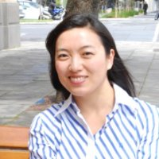

**Xiuping Liu (Ms.)**

Division Director

Division of American and Australasian Affairs

Bureau of International Cooperation

National Natural Science Foundation of China

E-mail: [liuxp@nsfc.gov.cn](mailto:liuxp@nsfc.gov.cn)

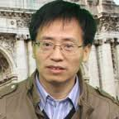**Dezhong Yao, PhD**

Director, Key Laboratory for NeuroInformation, Ministry of Education, China International Joint Research Center for NeuroInformation, Ministry of Science and Technology, China

Dean, School of Life Science and Technology, University of Electronic Science and Technology of China, Sichuan; Director, Center for Information in Medicine, University of Electronic Science and Technology of China, China

E-mail: [dyao@uestc.edu.cn](mailto:dyao@uestc.edu.cn)

<http://www.neuro.uestc.edu.cn/bci/member/yao/yao.html>

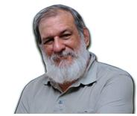

**Pedro A. Valdes Sosa**

Director Joint China-Cuba Laboratory for Translational Neurotechnology, University of the Electronic Sciences and Technology of China, Chengdu, China

Coordinator of Cuban Human Brain Mapping Project, CNEURO

E-mail: [pedro.valdes@neuroinformatics-collaboratory.org](mailto:pedro.valdes@neuroinformatics-collaboratory.org)

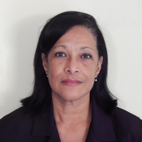

**Maria L. Bringas Vega**

Professor of Neuropsychology and Neuroinformatics.

Coordinator of the China-Cuba Joint Laboratory for Translational Neurotechnology. University of Electronic Science and Technology of China, Chengdu, China

E-mail: [maria.bringas@neuroinformatics-collaboratory.org](mailto:maria.bringas@neuroinformatics-collaboratory.org)

**CANADA**

[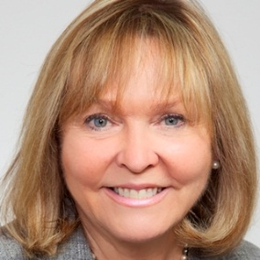](http://sciencepolicy.ca/maryse-lassonde)

**Maryse Lassonde**,

Director of the Royal Academy of Science Quebec, Canadá.

Director of the Research Fund for Quebec, Canada

Professor of Neuropsychology and Neurodevelopment at the University of Montreal and at the Sainte-Justine University Center.

e-mail: [maryse.lassonde@umontreal.ca](mailto:maryse.lassonde@umontreal.ca)

[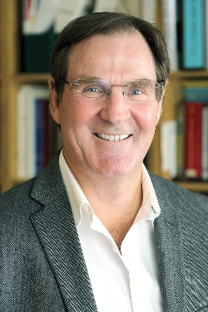](http://mcin-cnim.ca/wp-content/uploads/2014/05/Allan-Evans.jpg)

**Alan Evans, PhD,**

Director of Human Brain Mapping consortium, McGill University,

Prof. of Neurology, Neurosurgery MNI, Montreal, Canadá. President of Human Brain Mapping Organization OHBM

e-mail: [alan.acehigh@gmail.com](mailto:alan.acehigh@gmail.com)

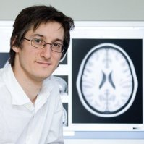

**Dr. Simon Duchesne**

Researcher at the Mental Health Institute of Quebec City, Department of Radiology, Faculty of Medicine, Laval University. Assistant professor, researcher and executive director of mental health of the consortium of Images of Quebec.

E-mail:  [simon.duchesne@crulrg.ulaval.ca](mailto:simon.duchesne@crulrg.ulaval.ca)

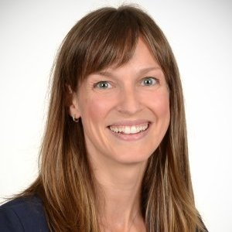

**Anne Gallagher**

Researcher in Neurosciences and Professor of Neurodevelopment at the University of Montreal.

E-mail: [anne.gallagher@umontreal.ca](mailto:anne.gallagher@umontreal.ca)

[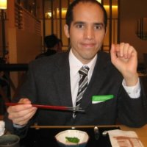](https://translate.googleusercontent.com/translate_c?depth=1&hl=es&prev=search&rurl=translate.google.com&sl=en&sp=nmt4&u=https://www.linkedin.com/start/view-full-profile?_ed=0_vAEIFu7uN-JceEoxuZX28M06yc2FFdJojMsTCwGnJeGvDrYqYlkEvUhCiHGmgoKN&trk=pprof-0-ts-view_full-0&usg=ALkJrhiPNhiJ6rwTa9Sczly4wZHtQM-YCA)

**Yasser Iturria-Medina**

Post-doct, Mc Connell Center for Brain Imaging, Neurological institute, Montreal, McGill University, Canadá

e-mail: [Iturria.medina@gmail.com](mailto:Iturria.medina@gmail.com)

**CUBAN PARTICIPANTS**

**CUBAN NEUROSCIENCE CENTER (CNEURO)**

* Mitchell Valdes Sosa (General Director , CNEURO)
* Vivian Reigosa Crespo (Deputy Director, Head of the Department of Applied Neuroscience, Cneuro)
* Maria Antonieta Bobes (Head of the Cognitive Neurosciences Department)
* Evelio González Dalmau (Head of Magnetic Resonance, Cneuro)
* Lidice Galan Garcia (Head of NeuroInformatics Department, Cneuro)
* Iris Rodriguez Gil (Department of Neuroinformatics, Cneuro)
* Eduardo Aubert Vazquez (Department of Neuroinformatics, Cneuro)
* Eduardo Martinez Montes (Department of Neuroinformatics, Cneuro)
* Jorge Iglesias Fuster (Department of Neuroinformatics, Cneuro)

**INVITED PARTICIPANTS**

* Danilo Alonso Mederos Vice President of the Cuban Ministry of Science, Technology and Enviroment
* Carlos Rodriguez Vicepresident of Cuban Academy of Science
* Ileana Morales (Director for Science and Technology, MINSAP)
* Zhang Zhibo (First Secretary of Science and Technology of the Chinese Embassy in Cuba) e-mail: [zhibo.zhang@umbc.edu](mailto:zhibo.zhang@umbc.edu)
* Luis Velázquez (Center of Ataxia, Holguín, Cuba)
* Karel A. Barberena (Technology and Information Company)